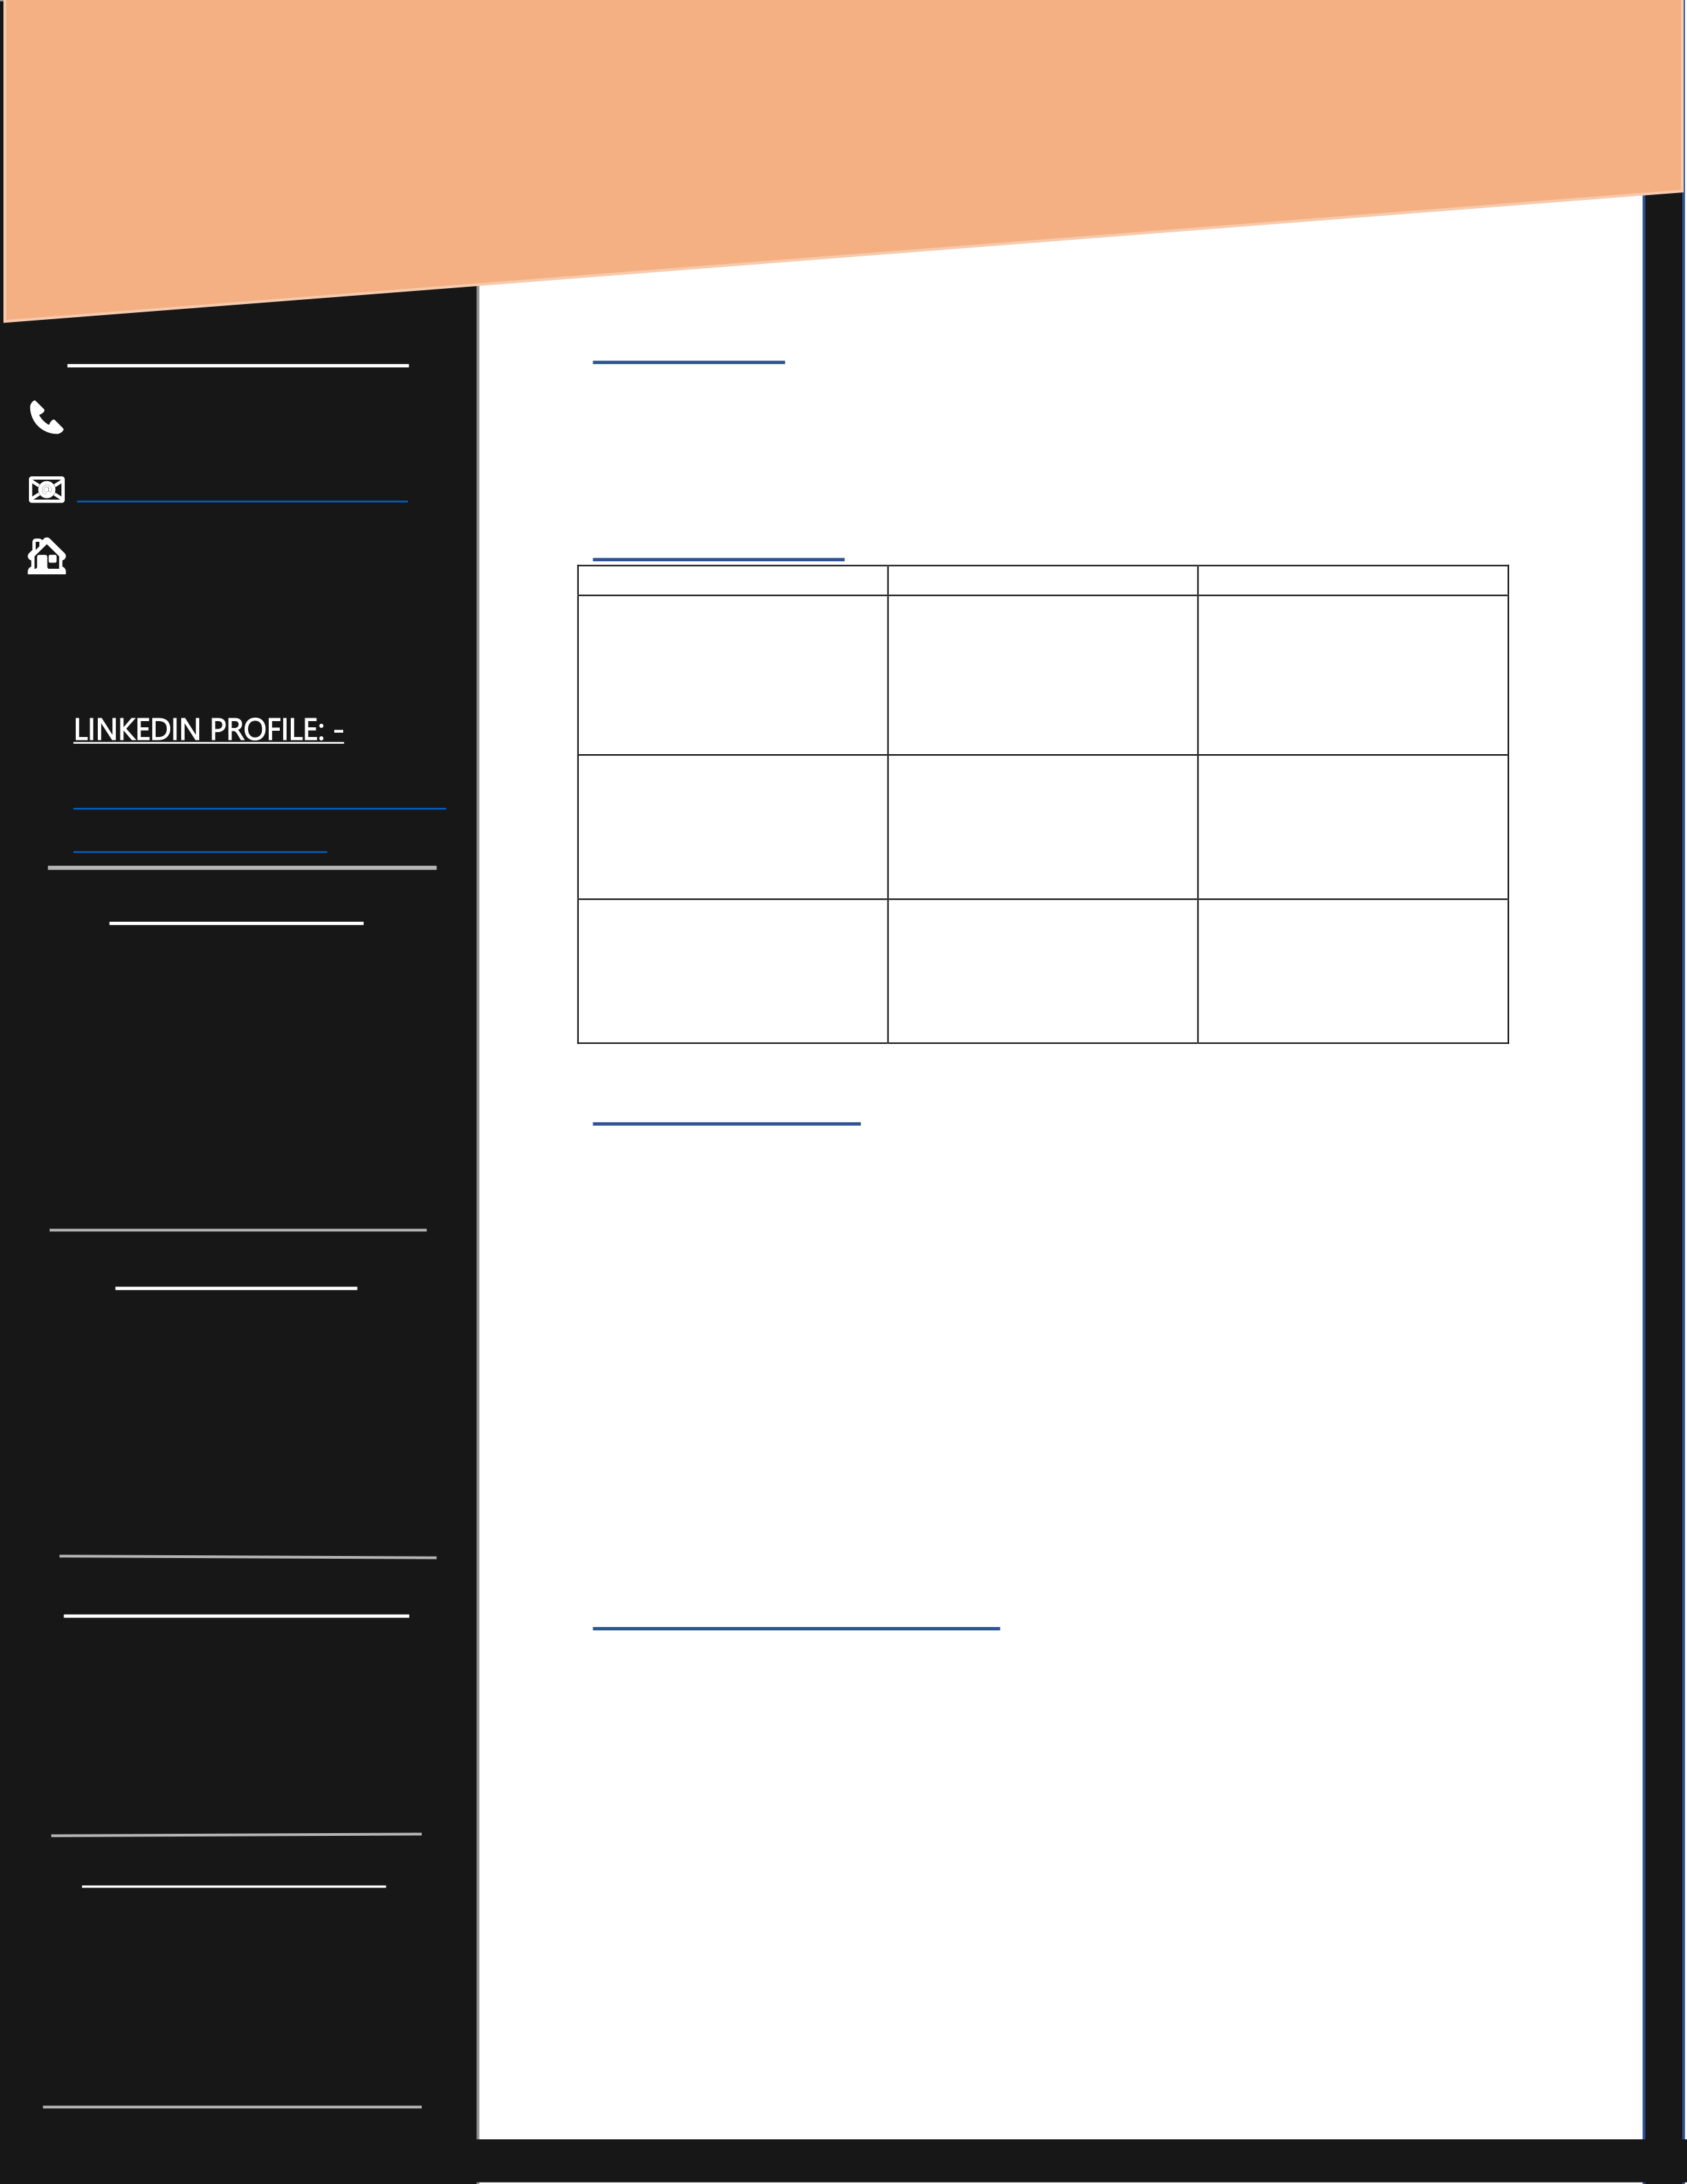

**HARMANSINGH** AHLUWALIA **B.Tech COMPUTER SCIENCE**

|  |  |  |  |  |  |  |  |
| --- | --- | --- | --- | --- | --- | --- | --- |
| **Personal Information:** 📞+91 8866084182  📧[harmans225@gmail.com](mailto:harmans225@gmail.com)  🏠 I-3 D.G Nagar Gadkhol Patiya, Ankleshwar,   Dist. Bharuch, Gujarat. | | | | **PROFILE: -**  To create a niche that will enable me to use my domain knowledge and professional skills along with my positive attitude which will contribute in the effective and consistent growth of the organization.  **EDUCATION: -** | | | |
| **Degree/Grade**  **B. Tech** CSE (CURRENT) | | **Institution**  DY PATIL  INTERNATIONAL  UNIVERSITY, AKURDI, PUNE | **Score** |
| **3rd Year: - Pursuing**  **2nd Year:- 7.5** / 10 CGPA **1st Year: -8.0** / 10 CGPA |
| • | LINKEDIN PROFILE: - | | |
| [http://linkedin.com/in/harm](http://linkedin.com/in/harmansingh-ahluwalia-02308a1b5) ansingh-ahluwalia- 02308a1b5   **Technical Skills:**  1.Languages: | | | | **XII** (CBSE- 2019) | | CHANDERBALA MODI ACADEMY,  ANKLESHWAR,  GUJARAT | **72%** |
| **X** (CBSE- 2017) | | CHANDERBALA MODI ACADEMY,  ANKLESHWAR,  GUJARAT | **8.4**/10 CGPA |
| • | | Python | |
| • | | C++ | | **EXPERIENCE: -**   →A mini project on **Movie Suggestion Web App** (Programming).  →A mini project on **Car Accident Alert System** (Entrepreneurship). →A project for our **College Library Web App** (Design Thinking).  →A mini project on **Bus Booking System** (DBMS)**.**  →A mini project on **Robotic Car** using **Arduino** (Embedded System). →A mini project on **Social Distance Maintaining Alert System** (Intelligent System).  **ACCOMPLISHMENTS: -**  • **Director | Administration** at **IMUN** (Interact Model United Nations). • Worked as **Origanising Committee Member** at **IIMUN** (India’s International Movement to Unite Nation). | | | |
| 2.Elementary knowledge: | | | |
| • | | DBMS | |
| • | | Data Structure | |
| • | | HTML | |
| **Software Skills:** | | | |
| • | | | PyCharm |
| • | | | Visual Studio Code |
| • | | | AutoCAD |
| • | | | Microsoft office |
| (Word, Excel, Power Point)  **Language Proficiency:** | | | |
| • | | | English |
| • | | | Hindi |
| • | | | Punjabi |
| • | Working as **Origanising Committee Member** at **TEDx Golden Bridge** for planning and Event Management. | | |
| • | | | Gujarati |
| **Hobbies & Interests:** | | | | • | Worked for **College’s fest** as a **core member** for organising the fest, also handling the Instagram account for the fest. | | |
| • | | Bhangra | | • • •  • | **Debate Enthusiast**  **COURSERA** certification of **7** courses.  Participated in the **Microsoft AI Classroom Series.**  Lead some of the social cause campaigns for TEDx GoldenBridge. | | |
| • | | Swimming | |
| • | | Badminton | |
| • | | Gym | |